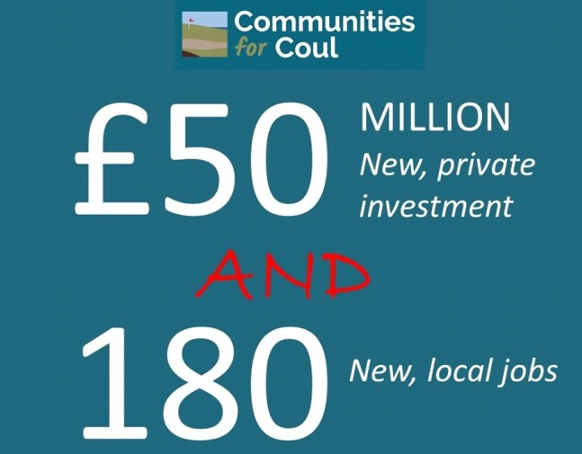

**Not Coul Reality Check June 2022**

More than 30 job vacancies in hospitality, retail and care sector

in Dornoch and Embo

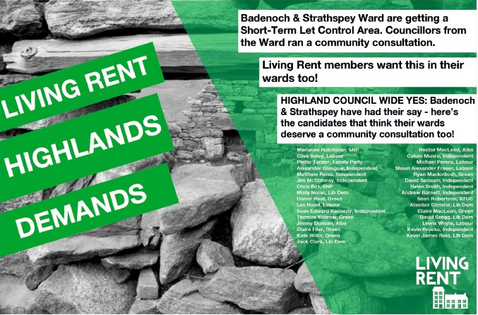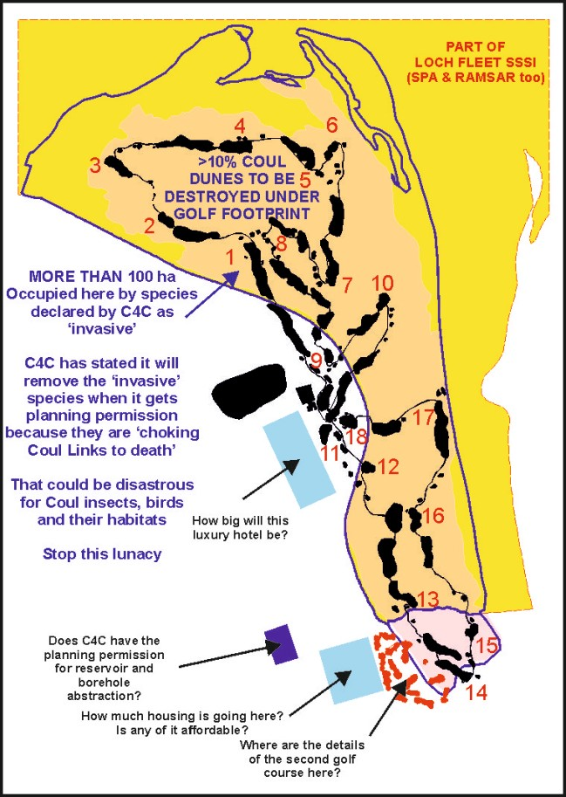

**Embo**

[**www.notcoul.org**](http://www.notcoul.org/)

**Not Coul is a group of local people formed in 2016 to oppose golf on superb triple-protected dunes**

**THIS IS MORE, NOT LESS, THAN 2017**

Fact: C4C Scoping Report lists more coming development than the

2017 planning applications (course, reservoir)

**Ask C4C why some new bits are missing today**

So, is the undeclared long-term plan really to transform wild Coul Nature into a tidy elite Coul Golf Resort?

Is this part of a Mike Keiser/Cabot Highland vision?

**Ask C4C**

**Ask C4C if this is worse than Trump**

What is the risk of SSSI/SPA/RAMSAR

denotiﬁcation?

Golf at Trump International’s Menie Links only removed an SSSI

**Just how many people are there to want these 180 promised jobs?**

*Answer: few*

There is a massive shortage of low-wage labour wanting work in Sutherland, as in all-Scotland

**40,000** hospitality vacancies in Scotland (BBC)

*LOCAL SE SUTHERLAND EVIDENCE*

Major local retail businesses are

**CLOSED OR PART-CLOSED** due to lack of staff:

*Dornoch Courtroom Bar/Restaurant Falls of Shin Visitor Attraction* Other shops closed on some days

June: no lunch at Royal Golf Hotel Dornoch

£25K per year jobs being re-advertised Local social media always full of job offers

**Ask C4C if high-end tourism and non-resident ownership are damaging communities**

**in Dornoch and Embo?** Too many second homes Too many holiday lets Too few rentals

Sky-high rents

Sky-high plot and house prices

**What is best for young families and the local economy: low-paid golf and hotel jobs** or **land plus diversiﬁcation?**

The minimum/living wage for most of the 180 C4C jobs cannot cover even the basics today

Sky-high rent or mortgage Sky-high energy bills Feeding a family

While locals struggle, others will come for their £150 pay and play

Most C4C jobs will be more of the local same: Inadequate low wages in a dire cost-of-living crisis Highly seasonal work, the result of a skewed

local economy over-reliant on golf and NC500 tourism

Could Coul Golf therefore **weaken the local economy?**

Increased inequality, recruitment harder for **many** other businesses

**Lots of young people could still be forced to move elsewhere unless the area ﬁnds**

**land for affordable ‘locals only’ homes and diversiﬁes away from golf and NC500 hospitality**

**How much of the above will be considered by C4C?**

**Ask C4C AND check for it in the application**

**BETTER PROSPECTS FOR LOCAL YOUNG PEOPLE?**

**HAS THE GOLF ECONOMIC CASE COLLAPSED?**

**EMBO 27 JULY 2022 QUESTION TIME**

**What to ask? - here are some suggestions to put to C4C** [**See www**](http://www.notcoul.org/)**.notcoul.org for detailed background**

**Not Coul expects questions submitted at Embo or by email**

**to be answered in writing and all made available on the C4C website Likewise, a full recording of the later Zoom session should be available online If C4C wishes to submit questions to Not Coul, answers will be posted online**

**COMMUNITIES FOR COUL (C4C)**

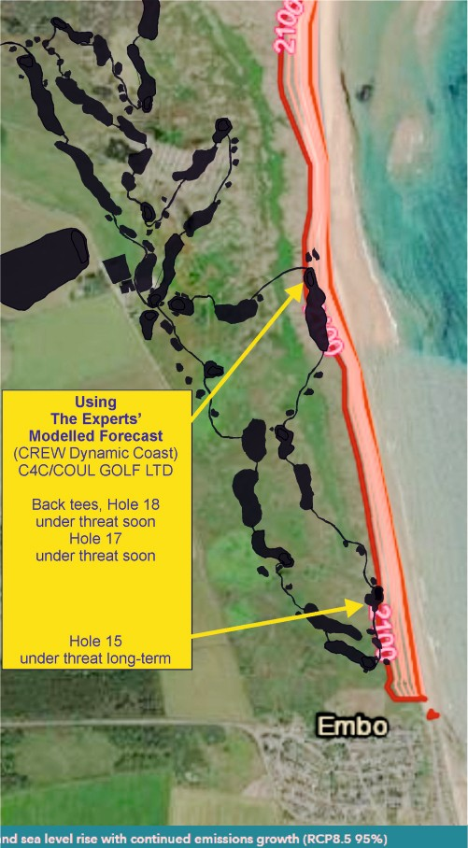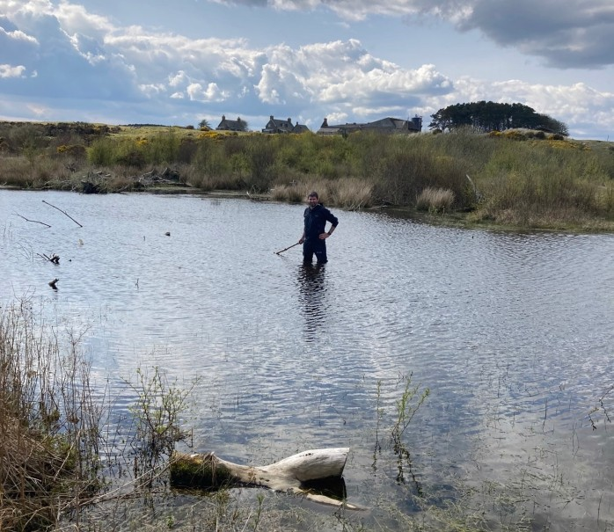

**Water problem landing area 11th fairway**

**Is all this water supposed to be on the fairway of a world-class course?**

**200m landing area, centre of Hole 11 First Fairway**

**Knee-deep water 28th April 2022, deepest water fell below ground around 13th July Soft mud and Common Spike-rush swamp with some Shoreweed most of summer World-class? - with narrow mown fairways of uncertain quality too. Ask C4C**

**Go look for yourself? NH8127394216 281273 894216**

**Lat 57.921449 Long -4.0060122**

**what3words: winemaker.dwarves.fabricate**

Beach Mean High Water 2021

Beach Mean High Water 2100

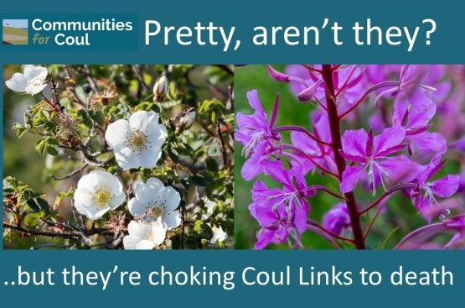

**This misuse of botany allows C4C to create a ﬁction about Coul:**

**“Soon there will be nothing much left worth preserving” (C4C Website: Environmental Stewardship page)**

**This is then used to traduce the quality of Coul dune slack and dune heath habitat (see Challenge below)**

***The Not Coul View***

**Slacks at Coul are both insect- and plant-diverse, with recent new discoveries. An offhand comparison with roadside ditches is demeaning.**

**Lichen interest in Coul dune heath, discovered only in 2018, has made the SSSI the best dune lichen site in the UK and perhaps in Europe. Mature dune heath is excellent, expanding. Gorse and birch are now being removed.**

**To ignore this good news and infer nondescript scrub instead is demeaning too.**

**There are concerns about the use of botanical information on the C4C website and C4C Facebook**

**Just one example is below, a claim that**

**two species of plant are 'choking Coul Links to death' This claim is certainly false for the Coul SSSI sector**

**The C4C aim is to create the wrong impression about Coul habitats That is potentially misleading the public to try to get support**

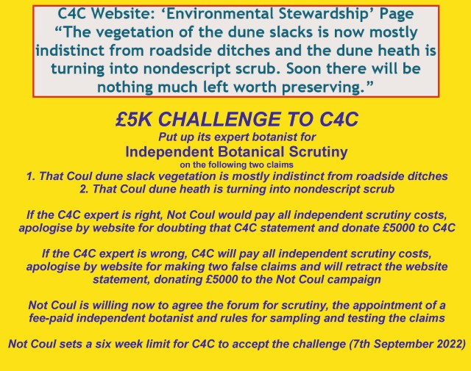

It is clear there is not suﬃcient local supply for so many low-paid jobs. Surely it is far too risky to develop golf courses and a hotel at Coul?

How will your big requirement for low-paid labour affect the staff recruitment and viability of other businesses in SE Sutherland?

Will your economic assessment cover labour supply as a project risk?

Why not avoid the SSSI and build a great artiﬁcial links course inland, like successes at Kingsbarns and Dumbarnie?

What is the Coul lost-ball search risk of Sheep Tick and Lyme Disease?

How does a golfer play the landing zone area on Hole 11 ﬁrst fairway? (see photo bottom right)

Will people winter walking on Hole 11 disturb protected birds like Teal? (See photo - wintering waterfowl frequent this hidden water body)

When will C4C name the experts responsible for its website info?

**Is there a way to get C4C to correct its website and Facebook information if it can be shown to be inaccurate or just plain wrong?**

**What are the coastal erosion and summer drought risks at Coul? How will C4C get rid of 100% deep moss cover on mown fairways?**

**How will mowing habitat create a Championship fairway**

**if it has 40-50cm tall heather or other woody plants, with suckers?**

Can C4C demonstrate how it will actually MOW a very wet dune slack, like the 200 metre landing area on the Hole 11 fairway? - see photo.

Why did the C4C Hole 4 move put a fairway on wetland (dune slack)?

**What is site integrity and will C4C damage it (Inquiry conclusion)?**

Will C4C mown fairways, greens and tees put Coul permanently in unfavourable condition, with SSSI integrity compromised?

Will SEPA ask for dune slack fairways to be moved (GWDTE)?

**GWDTE: Groundwater Dependent Terrestrial Ecosystem, EC Water Framework Directive**

How does C4C deﬁne ‘invasive species’ and what are the plant names on its list? Can C4C list the INNS that are in the SSSI at Coul?

**INNS: Invasive Non-Native Species**

How many gallons of herbicide will C4C use to remove C4C ‘invasives’ from the SSSI? Skibo used lots of gallons in June.

Will golf trigger the denotiﬁcation of the Coul SSSI dunes, as well as parts of the SPA and Ramsar sites?

Can C4C PROVE that it is not a front for the 2017 developers and the Coul landowner?

**IS GOLF HERE FOOLISH?**

**Government modelling suggests future erosion of two holes; major water problem on 11th Hole**

**£5K CHALLENGE TO C4C**

**STOP COMPROMISING COUL HABITATS**